PRESS RELEASE

The Legendary Satyajit Ray’s centenary celebrations on NFDC’s Cinemas of India OTT platform

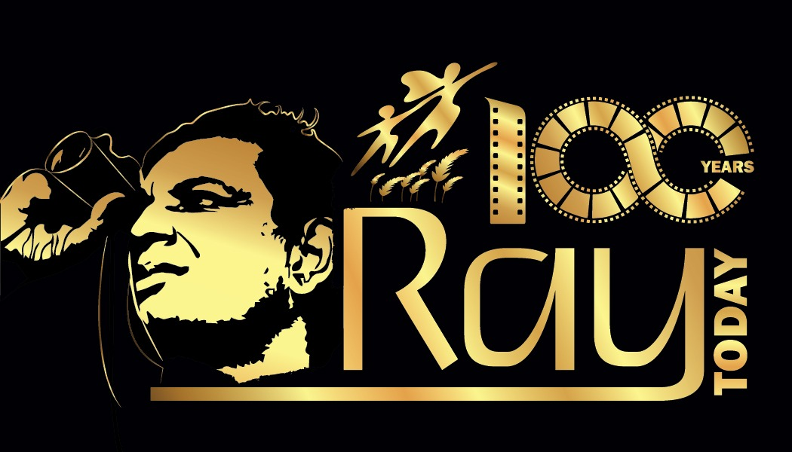

NFDC | Cinemas of India will pay tribute to Manik Da on his 100th birth anniversary by streaming a handful of his films between 02 -05 May 2021 for free & offering OTT’s subscribers during this period a gift hamper in association with Penguin Publishers.

April 2021, Mumbai –NFDC is organizing Satyajit Ray Film Festival on its OTT platform www.cinemasofindia.com with handful of classic by him and based on him. Satyajit Ray’s films are widely acclaimed and he’s the role model for many aspiring & emerging filmmakers. The film festival will stream classics like Ghare Baire (1984), Ganashatru (1989), Agantuk (1992) among few others that includes Anirban Mitra’s Nemai Ghosh - A ray of light (2018) documentary which is the story of an inspiring friendship, of the pursuit of artistic excellence and of a journey that started fifty years ago between Satyajit Ray & the bio-photographer Nemai Ghosh.
Satyajit Ray, regarded as one of world's greatest directors of the twentieth century, was born on 02 May 1921. His first film, Pather Panchali (1955), won eleven international awards, including Best Human Documentary Award at the Festival de Cannes (1956) and he was awarded an honorary Academy Award in 1992. Ray is recipient of the Bharat Ratna (1992) by the Government of India.

Ministry of Information & Broadcasting is greatly promoting the Birth centenary celebration of Satyajit Ray through the year and organizing Satyajit Ray Film screenings abroad through Indian Missions where these iconic films will be streaming as well. Films Division & other Ministry units are also actively promoting the centenary celebrations of Satyajit Ray in their unique ways.

National Film Development Corporation Limited (NFDC) will be offering gift hampers to 25 subscribers on www.cinemasofindia.com, on an annual subscription made between 02 -05 May 2021 on a first come first serve basis. This shall be a token of gratitude in these difficult times and to build long lasting relationships with its special audience.

NFDC is associating with Penguin Publishers for their kind gesture in bringing this together. The offer can be availed by the subscribers who takes a yearlong subscription of INR 599/- between 02 - 05 May 2021.The first 25 Subscribers will win 2(two) books with Satyajit ray's illustrations and short stories published by Penguin Publishers with a collectible NFDC Film DVD as a gift hamper package.

The books include, Satyajit Ray in 100 Anecdotes, it has gorgeous line arts that complement the text to create an engaging book that readers will enjoy reading, one of a kind book to introduce the genius of Satyajit Ray to readers young and old. Another Dozen Stories - it’s collection includes twelve hair-raising stories that will leave you asking for more! Translated for the very first time into English by noted translator Indrani Majumdar, this edition is a tribute to Ray’s immaculate literary genius and a gift for his many fans and followers on the centenary of his birth.

Smt. Dhanpreet Kaur, Director, Films, (Ministry of I & B) & Managing Director NFDC India, also shared
her views on the new festival– “Ministry of I & B is elated to open the grand centenary celebrations of the legendary filmmaker Satyajit Ray. It is indeed a pleasure to organize the film festival on NFDC’s OTT Cinemas of India, Ray’s films are renowned globally, its always a learning experience watching his films. Hope the audiences enjoy the films all over again”

Shri Anirban Mitra, Director shared, “Nemai Ghosh: A RAY of Light, is a moving story of how an ordinary man came to be associated with a giant of cinema Satyajit Ray and became the photo-chronicler of his creative and personal world. It also pays tribute to the elegance of black-and-white films and the nuances of analogue photography. The cinematography has been specifically designed to reflect Chiaroscuroóthe blending of light and shade which both Ray and Ghosh admired and followed. This is the story of an inspiring friendship, of the pursuit of artistic excellence and of a journey that started fifty years ago…And we are pleased to present this film on NFDC Ray Centenary Festival. The film's screened in 6 countries, 10 cities within India and 14 Film Festivals, garnering 4 Awards & special mentions.”

About NFDC India
Incorporated in the year 1975 National Film Development Corporation Ltd is formed by Ministry of Information and Broadcasting (Government of India) with the primary objective of promoting the good cinema movement in India. NFDC is instrumental in creating an ecosystem to support the financing, distribution and development of independent films across the country in various Indian languages.

About Penguin India
It is a part of Penguin Random House, a global trade publisher. Penguin came to India in 1985 and began publishing in 1987, with only six books in its catalogue. They are now thirty-five years young in the region, publishing over 250 new titles every year, with an active backlist of over 3,000 titles. In India, they have grown to become one of the most recognized names in publishing. in Hindi and other regional languages.

Note: Post subscribing to the www.cinemasofindia.com OTT platform between 02-05 May 2021 for availing the offer click here. For enquires related to the offer write to info@cinemasofindia.com

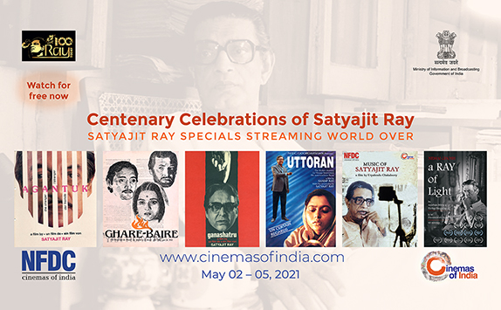

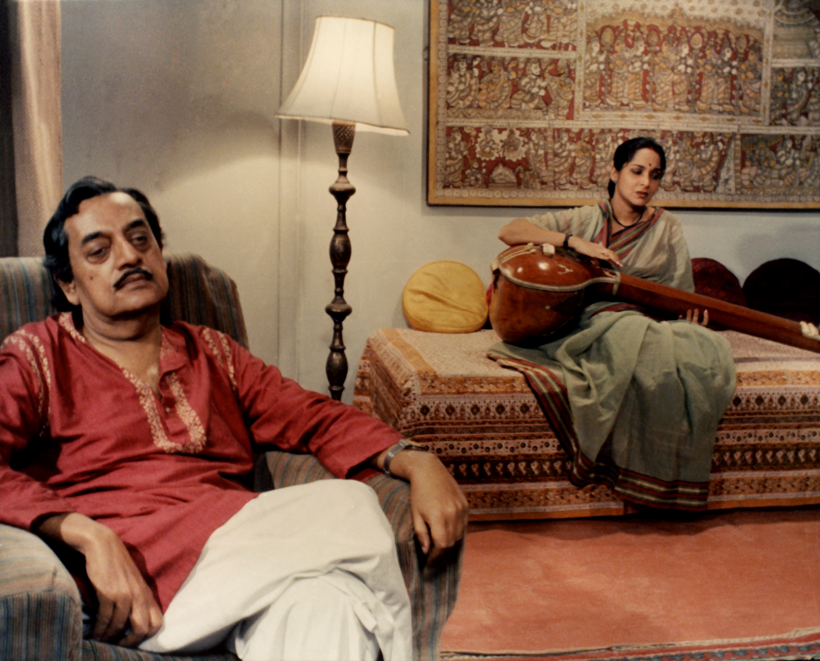
Still from the movie Agantuk
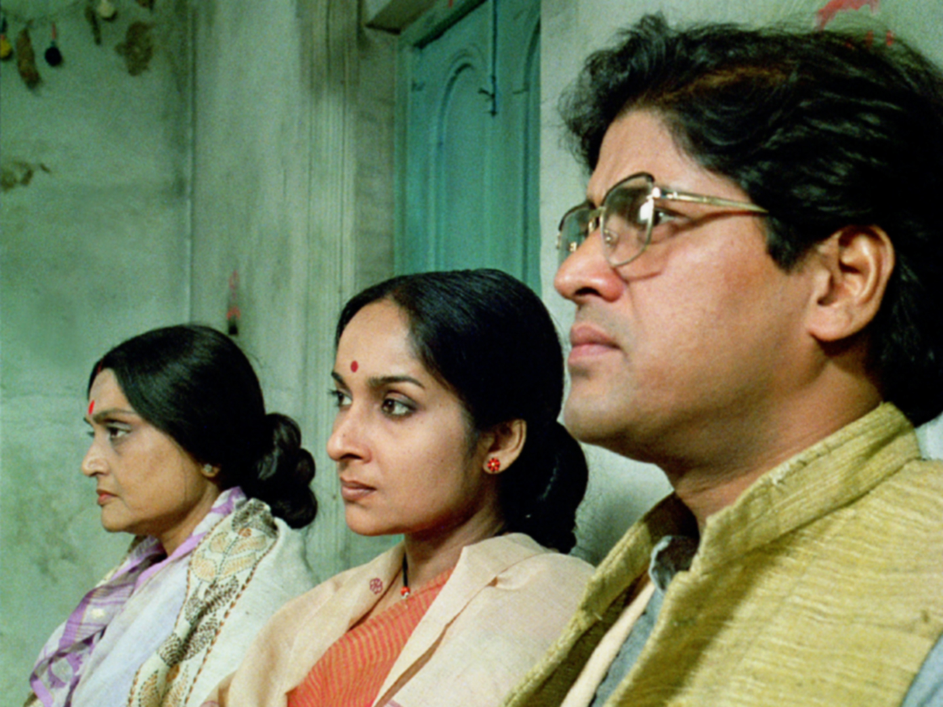
Still from the movie Ganashatru

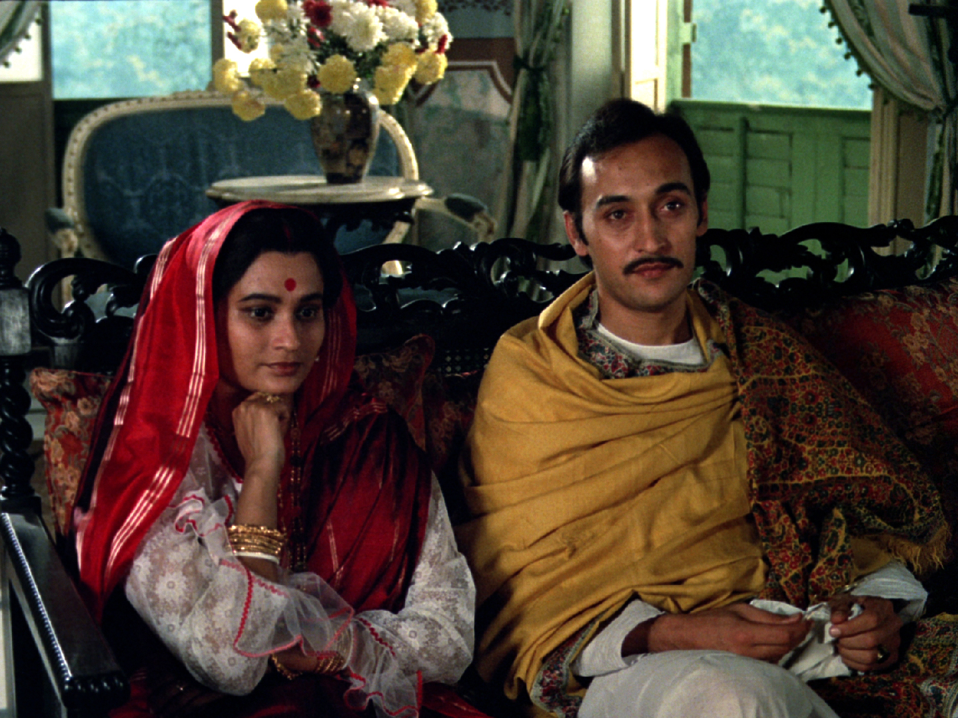Still from the movie Ghare Baire
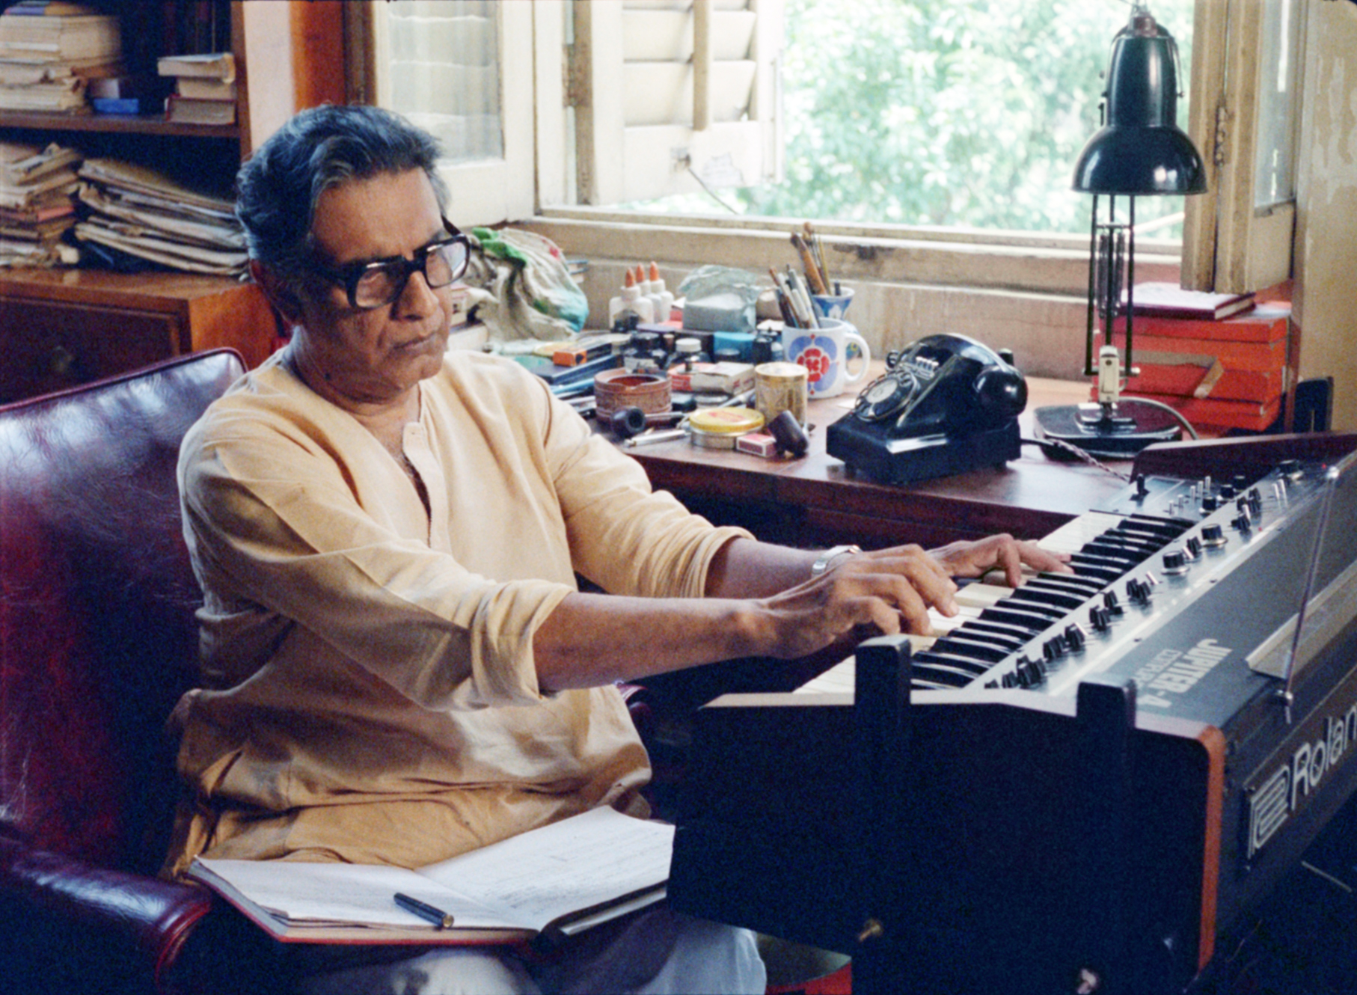Still from the documentary Music of Satyajit Ray

